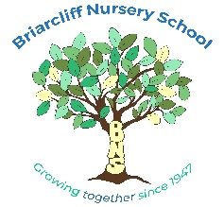
40 Morningside Dr. Ossining, NY 10562
914-941-4373 Fax 914-941-4453
director@briarcliffnurseryschool.com
administrator@briarcliffnurseryschool.com

Application for the 2023-2024 School Year
(New Students Only)

Child’s Name__________________________________________________________________

Primary Phone________________________________________ Birthdate______________

Primary Email_______________________________________________________________

Parent’s Name/s_____________________________________________________________

Address______________________________________________________________________

Session Requested
(Please indicate your 1st, 2nd and 3rd choice)

2’s Classroom  8:55-11:50 | 5 days (M-F)
 | 3 days (M-W)
 | 2 days (Th,F)
For Incoming 3’s families who are interested in 3 or 4 days, please indicate which days of the week you prefer.

3’s Classroom  9:10-12:05 | 5 days (M-F)
 | 4 days (days vary)
 | 3 days (days vary)

4’s Classroom  9:00-11:55 | 5 days (M-F)
** Start times may change slightly

Signature Date

Please return this form along with a $100 non-refundable application fee payable to Briarcliff Nursery School.

---------------------------------------------------------------------------------------------------------------------------------------------
Check #__________________ Date_______________________ Amount_________________

Credit Card Authorization Received ______ Yes ______ No

