Calling all animal lovers! Our theme this summer will be ANIMALS. The children will explore animals through play, art, music, and stories. Each 2-week theme will provide our campers with opportunities to learn more about different habitats, the animals that live in them, and what we can do to help protect them.
Weeks 1 and 2:  June 13th -June 24th | Ocean Animals  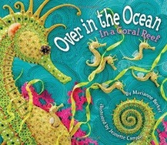
Weeks 3 and 4:  June 27th to July 8th | Forest Animals  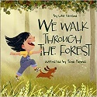
Weeks 5 and 6:  July 11th – July 22nd | Jungle Animals  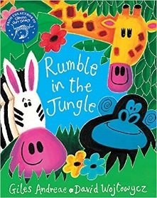
Week 7:  July 25th -July 29th | Pets  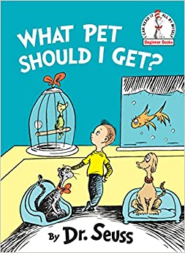

Why choose the BNS Summer Program?
- Our very own BNS teachers make up our summer program staff, ensuring that the children are in responsible, experienced, and caring hands.
- Children will spend most of the day exploring our expansive outdoor space featuring endless opportunities for gross and fine motor play, nature discovery, social interactions, sensory experiences, pretend play and so much more!
- Families can pick and choose the weeks and schedule that works best for them!
- We have a beautiful “Garden Room” that will enable children to move from the inside to the outside more fluidly. We can also use the Garden Room space to set up special thematic activities and pretend play props.
- BNS Camp is fun!! We respect summer as a time when we can all take a breath, enjoy what nature has to offer, and make the most of our time together. Music, art, cooking, pretend play, literacy activities, and movement will be weaved throughout the entire summer.

