This summer your children can explore the depths of the ocean, go on a camping adventure with their friends, run their own bakery, and become superheroes….
all from our very own BNS backyard!
Our theme this year is “Let’s Pretend” and we will encourage the children to tap into their creative, imaginative sides while we give them the time, space, resources, and support to make the most of each pretend scenario that we explore.
Weeks 1 and 2:  June 14th -June 25th | Let’s pretend  we are  OCEAN EXPLORERS!  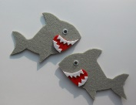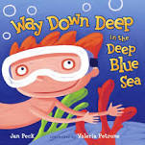
Weeks 3 and 4:  June 28th to July 9th | Let’s pretend  we are  GOING CAMPING!  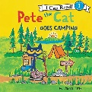
Weeks 5 and 6:  July 12th – July 23rd | Let’s pretend  we are  BAKERS!  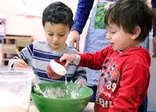
Week 7:  July 26th -July 30th | Let’s pretend  we are  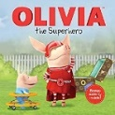  SUPERHEROES!

Why choose the BNS Summer Program?
- Our very own BNS teachers make up our summer program staff, ensuring that the children are in responsible, experienced, and caring hands.
- Children will spend most of the day exploring our expansive outdoor space featuring endless opportunities for gross and fine motor play, nature discovery, social interactions, sensory experiences, pretend play and so much more!
- We have experience running a summer program during the pandemic and have used what we learned last year to strengthen our health and safety practices.
- Families can pick and choose the weeks and schedule that works best for them!
- We have a beautiful new “Garden Room” that will enable children to move from the inside to the outside more fluidly. We can also use the Garden Room space to set up special thematic activities and pretend play props.
- BNS Camp is fun!! We respect summer as a time when we can all take a breath, enjoy what nature has to offer, and make the most of our time together. Music, art, stories, and movement will be weaved throughout the entire summer.

