Yoga & Mindfulness for Kids
At Briarcliff Nursery School

Young Yogis from Yoga Heights: A Child’s Foundation to Cultivating Their Best Selves

Offered as a modern pre-k curriculum that compliments the early childhood education and together educates the whole child. Our methodology teaches social and emotional learning skills through a mindfulness approach to movement and breath - all in a fun and engaging manner that kids enjoy.

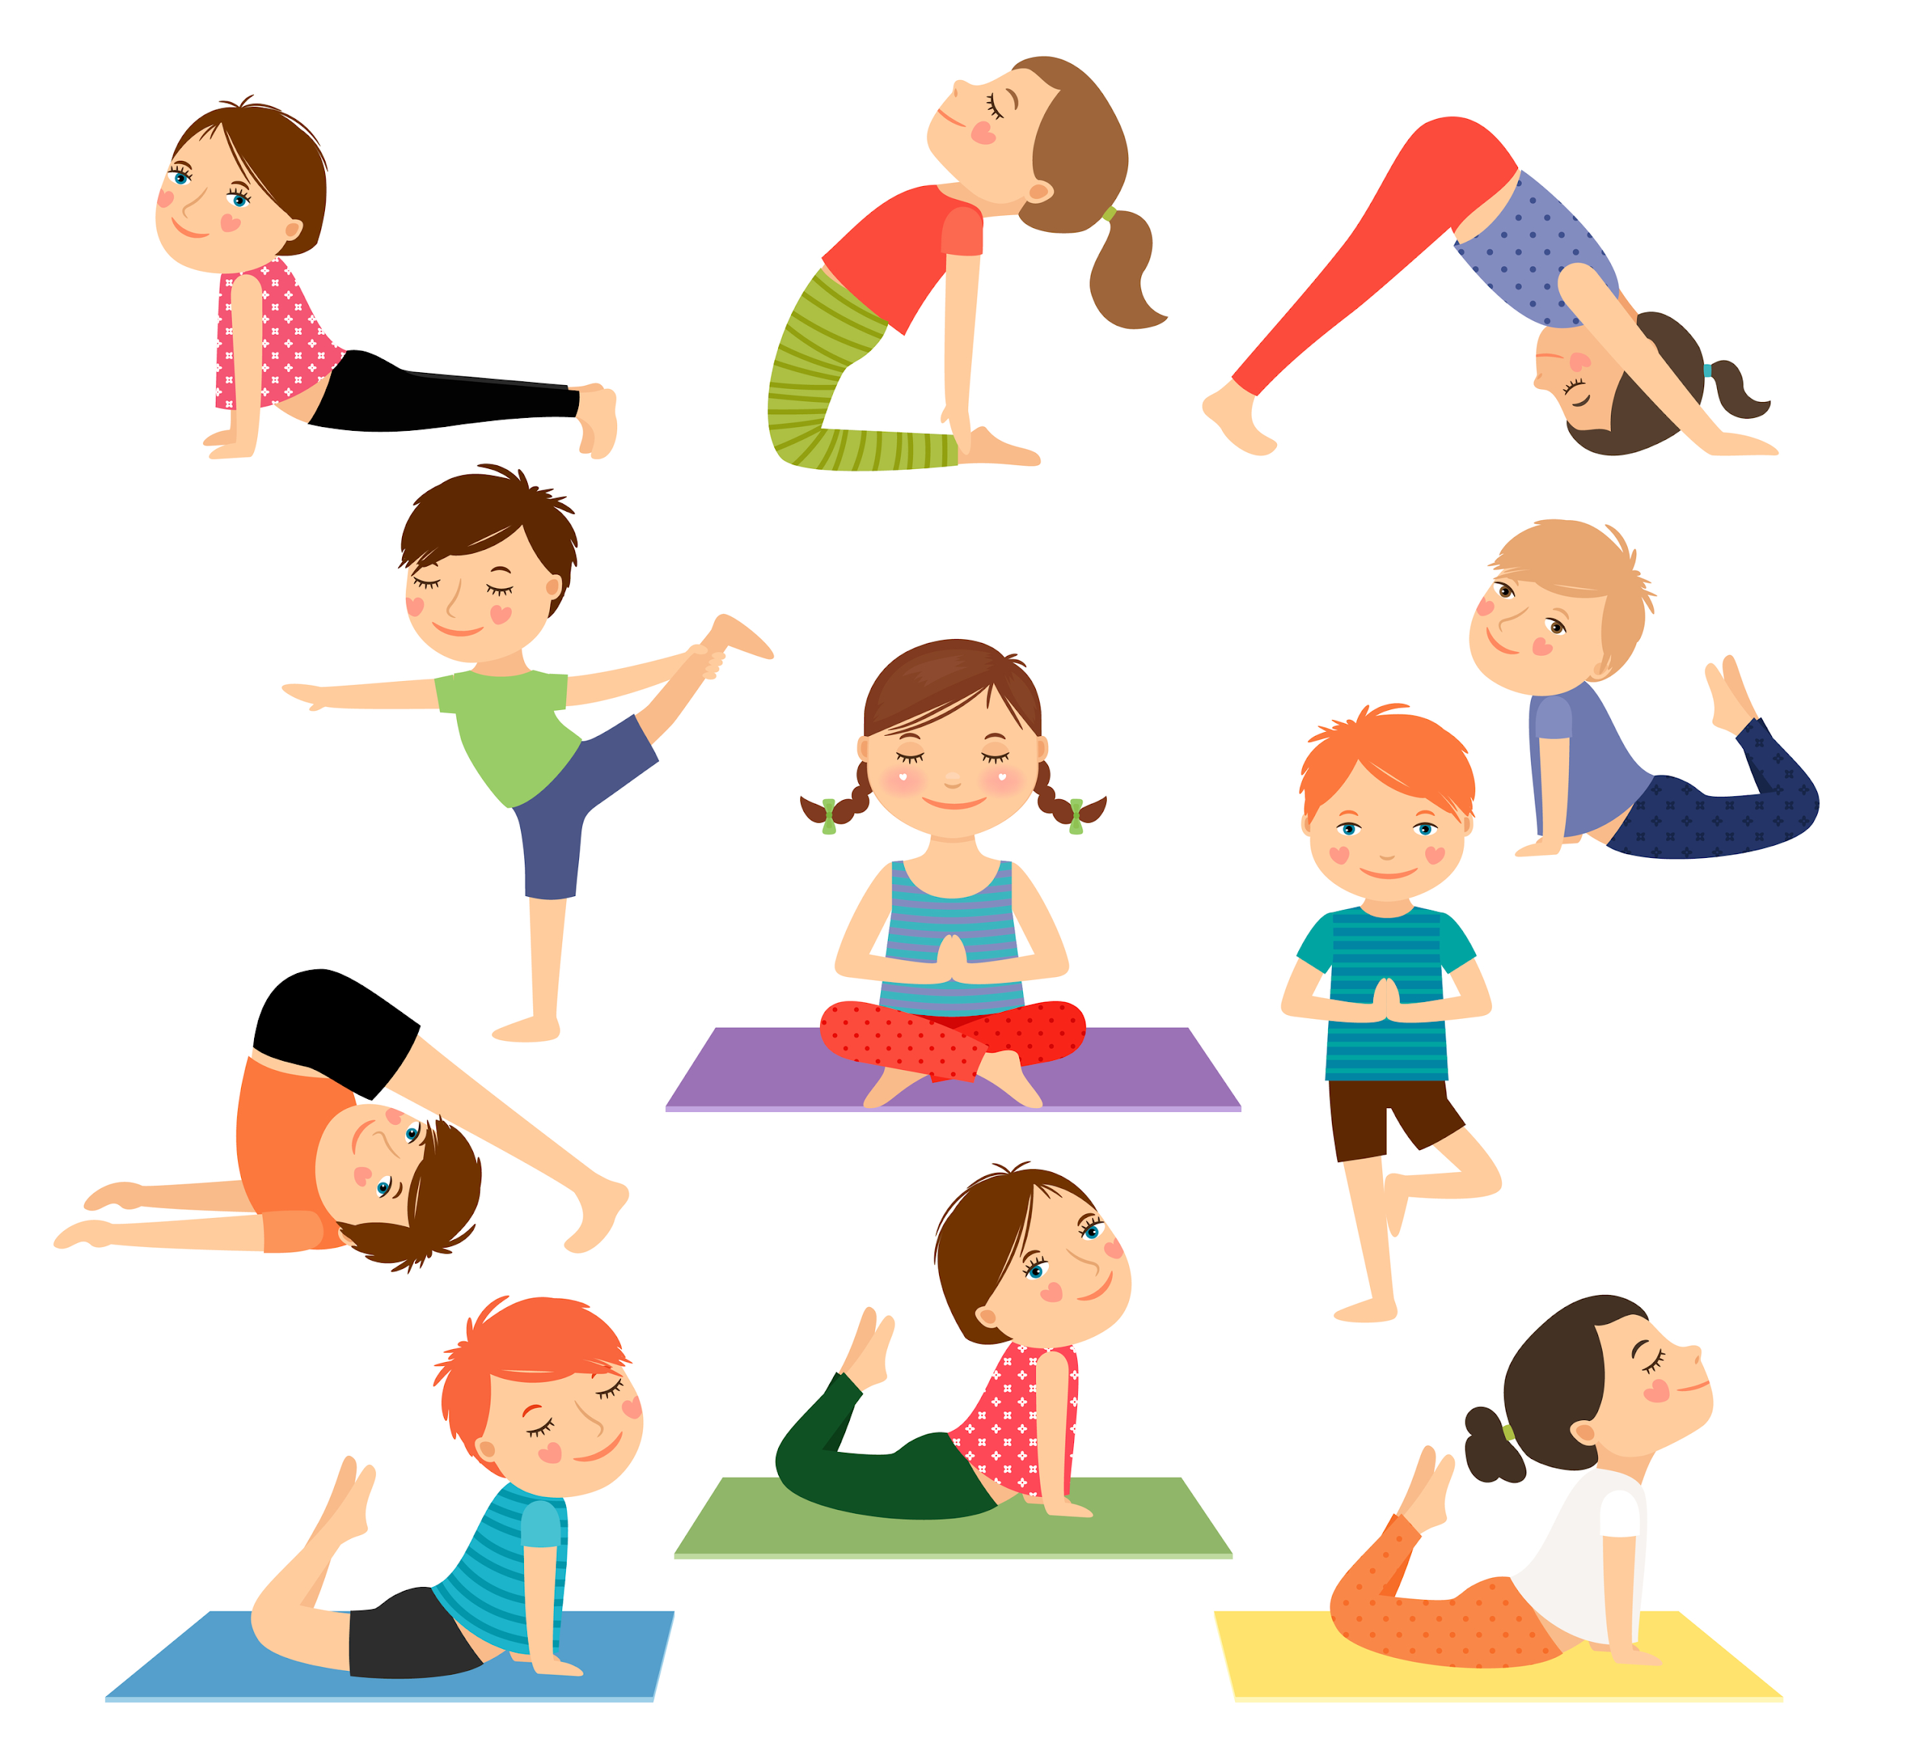

Coming Spring 2020 - Wednesdays 12:15-1:15pm
8 Classes: $225 (materials provided)

Yoga Heights Kids
Spring 2020 Registration

Participant:__________________________Age:_________Parent Name:______________________________________
Address:___________________________________________
City:__________________State:__________Zip:__________
Phone:____________________Cell:____________________ Email:_____________________________________________
Emergency Contact:_______________________________
Phone:____________________________________________

Any condition/s that may limit student’s participation in class:

Classes are based on the teachings of Little Flower Yoga and taught by Rene Biemer, who is certified in their teachings.
Wednesdays: 12:15-1:15pm on 3/18, 3/25, 4/1, 4/15, 4/22, 4/29, 5/6, 5/13 (make-up date will be 5/20 if necessary)

Yoga Heights, LLC, Yorktown Heights, NY 10598
Rene Biemer, RYT, RCYT
To Register, please email Rene at Renebiemeryoga@gmail.com.
For questions call 917-846-6731. Cash, check or Venmo

