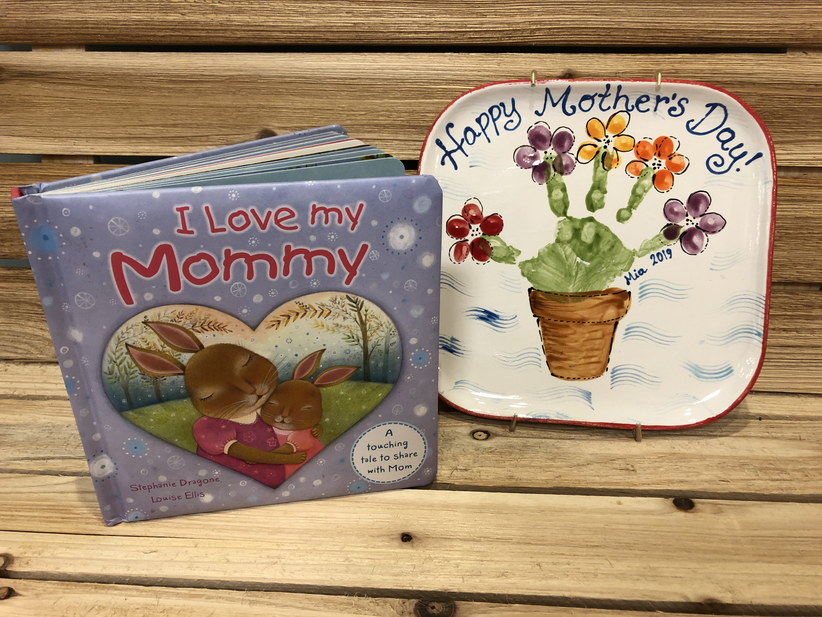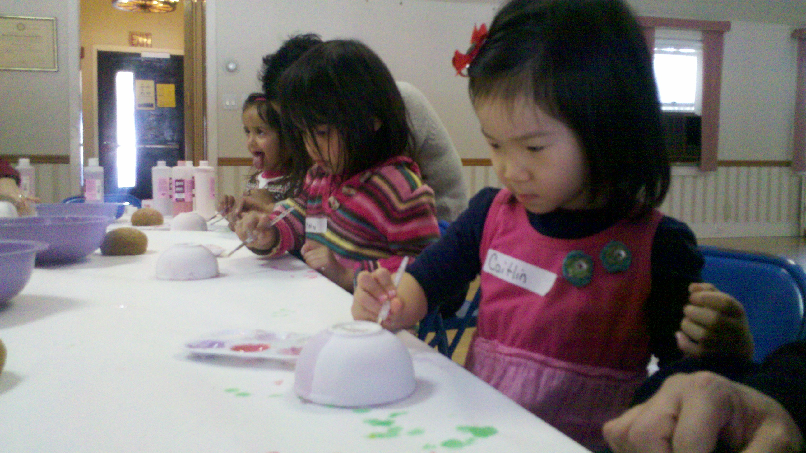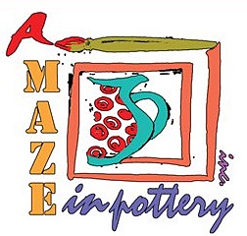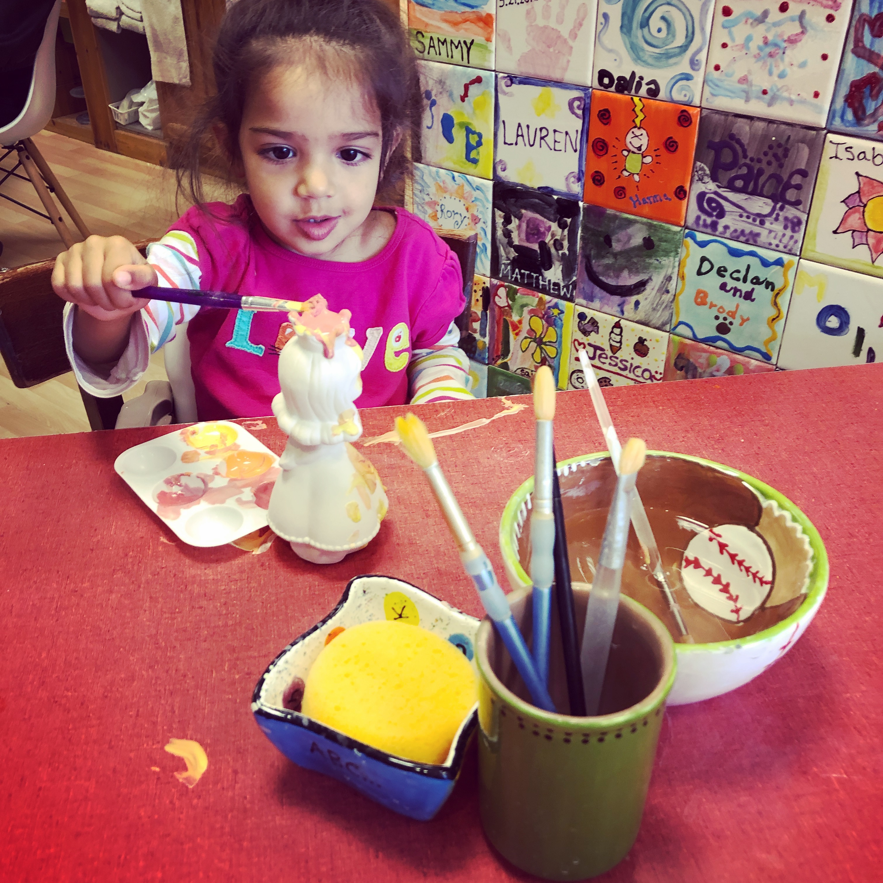

Tuition for this 8 weeks session is $245 + sales tax

All credit cards, check and cash accepted

For registration call or email our studio

A maze in Pottery

76 N State Rd

Briarcliff Manor, NY 10510

914-502-0088 amazeinpottery@gmail.com

www.amazeinpottery.com

**A Maze in Pottery**

is coming to

Briarcliff Nursery School

Details:

Wednesday 12:15-1:00 PM for ages 3-4

1/8, 1/15, 1/22, 1/29, 2/5, 2/12, 2/26,3/ 4

(no class 2/19)

During our Listen’n’Paint classes children will have fun painting a pottery project based on a story which will be read by the teacher in a short break.

During this 8 weeks session they will be painting a different fun project each time. The projects will be both: decorative and functional. Our little painters will bring home bowls, plates, cocoa mugs and more which can be used everyday, dishwasher and microwave safe.

Children will be encouraged to use various pottery painting techniques, like brush, sea sponges, q-tips, splattering, tapes, and stickers.

All material are non toxic.

+