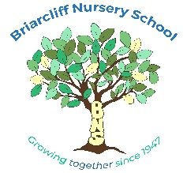
40 Morningside Dr. Ossining, NY 10562
914-941-4373 Fax 914-941-4453
director@briarcliffnurseryschool.com

2020-2021 APPLICATION (New Students Only)

Child’s Name__________________________________________________________________

Primary Phone________________________________________ Birthdate______________

Primary Email_______________________________________________________________

Parent’s Name/s_____________________________________________________________

Address______________________________________________________________________

Session Requested
(Please indicate your 1st, 2nd and 3rd choice)

2’s Classroom  9:00-11:55 a.m. | 5 days (M-F)
 | 3 days (M-W)
 | 2 days (Th,F)
For Incoming 3’s families who are interested in 3 or 4 days, please indicate which days of the week you prefer.

3’s Classroom  9:00-11:55 a.m. | 5 days (M-F)
 | 4 days (days vary)
 | 3 days (days vary)

4’s Classroom  9:00-11:55 a.m. | 5 days (M-F)
Does your child have any special medical or learning needs that we should be aware of? If so, please explain. This information will not impact admission in any way. This information is very helpful in terms of thinking about the number of kids, staffing, and grouping.

Signature Date

Please return this form along with a $50 non-refundable application fee payable to Briarcliff Nursery School.
Check #__________________ Date_______________________ Amount_________________

Credit Card Authorization Received ______ Yes ______ No

